11.01
Capability List
Process Design & AMOS Configuration Document
Purpose
This Process Design document is provided to Key-Users to record their key decisions regarding the AMOS Process design and the required AMOS configuration.
It is updated throughout the Project Definition Phase and used as the baseline for the Final Acceptance prior to Go-Live
Revision
Author, Name | Date | Notes
Marcel Moser | 01.06.2024 | First version

Table of Contents
1. Process Overview & Objectives 3
2. Regulatory References 3
3. Definitions & Glossary 4
4. Process Tasks 4
5. Process Dependencies 4
6. Process Flow 5
7. Process Design Questions 6
8. Data (Source) Mapping 7
9. Other Software Used 7
10. AMOS Configuration 8
a. Basic Data 8
b. Parameters 8
c. Workflows 8
d. Scheduled Tasks 9
e. API’s & Interfaces 9
11. Annex – Additional Info 9

Process Overview & Objectives

Process General Description:
To create, record and maintain the internal and external Shop Capability List (APN 935)
Shop Capability in General
After the company’s commercial decision to build up for a certain part number (group) capability, certain internal setups are required:
- Facility buildup
- Documentation
- Tools/Test Equipment
- Training of Shop Staff
- Staff (re-)Certification Process

Main Process Objective (Outputs & Outcomes):
Shop Capability Setup in AMOS
- Define Shop in Address Administration (APN53) as a sub-address of your Station with the Property Internal Shop "IS" and approve the shop under the "Certificates tab".
- In Basic Data Administration (APN18), define your capability types.
- In APN18, define your Class and Rating System to be used for the Approval of Maintenance Organisations. The default ratings in the table refer to authority EASA, Annex II (Part-145): Aircraft (A1 - A4); Engines (B1 - B3); Components other than complete engines or APUs (B1 - B22); Specialised services (D1).
The table lists the rating (Code), the description of the rating (Description) and the authority (in Address Administration) where the rating has been approved (Authority). Link the internal shop address with the rating in APN59/Part Administration/Miscellaneous/Capabilities tab.
- Control the component maintenance manuals (CMM from the OEM) in APN565/Publication Management.
- Setup the personal component maintenance approvals in APN146/Staff Management.
- The Shop Capability Report (APN935) provides the full overview about your company's capabilities.
Whenever a part is processed via Repair Administration (APN1431) the Internal Shop(s) and its capability is proposed as repair station and if confirmed a Component Workpackage from the generated R-order can be issued to be processed in Component Workpackage (APN1084).

Regulatory References

- EASA Part-145, Annex II, No 1321/2014
  - Sections 145.A.25/ A.30/ A.35/ A.40/ A.42/ A.45/ A.47/ A.48/ A.50
- FAA 14 CFR Part 145
  - Sections: 145.51/.53/.55/.57/.59/.61/.63/.103/.105/.107/.109/.151/.153/.157/.159/.201/.205/.211/.213

Definitions & Glossary

Keywords | Explanation
Internal Capability | Authority approval to repair, overhaul, inspect, etc. a certain part number (part number group).
External Capability | If no internal capability is available, parts must be sent to extern approved repair station that is holding the required capability
PSOG | Part Sign Off Group

Process Tasks

Business Process Task / Actions / Activities:
- Based on existing list of Suppliers and Addresses, the relevant capabilities are defined in the address level.
- From the address level, capability-relevant information is then set on the Part Number (P/N) level.
- The capability on the P/N influences the creation of Repair Orders, as well as the execution of Component Workpackages in organic shops.

Process Dependencies

INPUT | CONCURRENT | OUTPUT
- 04.01 – Company Organization  - 09.02 – Supplier Management | - 02.05 – Technical Library: It updated based on new capabilities acquired or renewed | - N/A

Process Flow
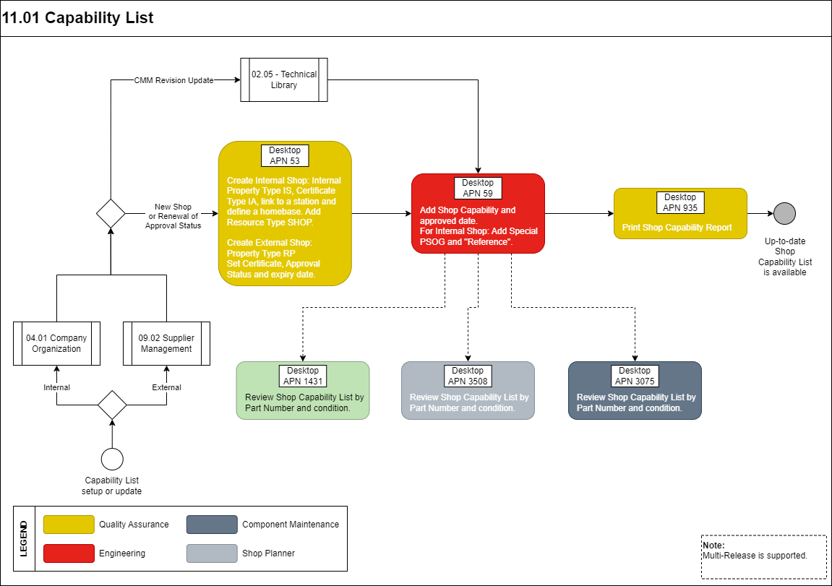

Process Design Questions

# | Question | Answer
1 | Do you have internal shops?
2 | Which capabilities do your shops have? (Detailed list with P/N and capability)
3 | Which Authority Approvals do you have?
4 | How does your company maintain the Capability list?
5 | How does the mechanic prove his work (experience) on a part number to keep the capability?
6 | Who is maintaining the publications related to Parts?
7 | In case of a new publication that affects the Capability, how is the revision process managed today?

Data (Source) Mapping

Data Sources | Description | Volume / Manual / Automatic / Static / Dynamic
XPARTCAP | Part Capabilities  (to be used in conjunction with Parameter 1241)

Other Software Used

Other Software | Used by: | Description

AMOS Configuration

Basic Data

Basic Data Table | Notes
Capability Ratings | Class and Ratings System to be used for the Approval of Maintenance Organisations.
Capability Type | This table contains the different capability types which can be used in Part Administration / Shop Capability.

Parameters

Parameter Code | Parameter Name | Notes
1149 | PQS EVENT CLASS FOR PART CAPABILITY | This parameter defines which Qualification Class represents a Part Capability
1240 | CAPABILITY INTERVAL (IN MONTH) | This parameter defines the interval which will be applied to the expiry-date of part capability (PQS) after closing a Component Workpackage

Workflows

Workflow Number | Workflow Name | Notes
65 | Part Capability Changed | This workflow is triggered when a part capability is entered/modified/deleted in the system.

Scheduled Tasks

Scheduled Task Reference | Frequency | Notes
PartCapabilitiesExpirationCheck | Daily (weekly as a minimum) | This task checks the approval dates of existing part capabilities and retrieves a list of capabilities whose approval is no longer valid based on the Approval date validity (days) parameter, located at the Details tab

API’s & Interfaces

Reference | Direction | Trigger | Frequency
N/A | N/A | N/A | N/A

Annex – Additional Info

N/A

